SUMMARY
of Local and Regional Development Policies in Ukraine

Implementation period:
August - September 2021

Prepared by:
Yehor Kyian, Yulia Protsenko

September 2021

ABOUT THE PROJECT

The current summary was developed within the project “Strengthening democratic resilience of key public institutions in Ukraine”. The initiative is being implemented by the International Centre for Policy Studies (ICPS) in partnership with the Institute for Economic and Social Reforms in Slovakia (INEKO) and is financially supported by the Embassy of the United States in Kyiv, Ukraine. The project aims to improve the efficiency of the state administration, self-government and civil society in the area of creation and oversight of regional policies. It also aims to increase transparency and independence of key regulatory and judiciary institutions as well as transparency and financial stability of the biggest state-owned enterprises and local authorities in Ukraine.
The publication presents the assessment of policies at the local and regional level, implemented in August - September 2021. Altogether, 30 regulations were gathered and ranked during the project.
The main objective of the initiative is to improve the quality of regional and/or municipal regulation and legislation through publishing a regular expert assessment of the socio-economic measures proposed or implemented by local governments in Ukraine. The purpose of the evaluation is to describe and promote reform and anti-corruption practices that can be transferred to other localities as well. At the same time, the critical assessment of non-transparent and inefficient measures should discourage representatives of local and regional authorities from their implementation.
The policies included in the current summary were identified and analyzed with the support of the Evaluation Council experts who were selected by the International Centre for Policy Studies on the basis of their experience. Six experts with sufficient experience were asked to assess the chosen local measures and policies, adopted by local and regional authorities.
As a result, six local and regional measures are described in this publication. In addition, this publication summarizes the policy evaluation results for 2020-2021.
We hope that these practices can promote good ideas and inspire their implementation throughout Ukraine.
SUMMARY

In this bulletin, the experts collected interesting materials about the measures that were implemented in different parts of Ukraine and analyzed their impact on the community and regions.
In particular, they assessed an important measure that will bring Ukraine closer to energy independence and reduce the dependence from the Russian Federation: the opening of a storage facility for used nuclear fuel in Chernobyl by the 30th anniversary of Ukraine's independence.
Measures in the field of education are important for Ukraine's approach to intellectual independence. Experts positively assessed the launch of the public budget for schools in order to involve students in the development of public space and in the cooperation with local governments in Ternopil. This practice is being picked up and implemented by other cities in Ukraine. These measures will have a positive effect in the future.
Also, given the lack of schools in large cities and the lack of good conditions in educational institutions in many regions of the country, the renovation of the school in Odessa with the support of the European Investment Bank will affect the quality of education of schoolchildren and increase the level of education in general.
An expert from the city of Khmelnytsky tested on her own experience whether a rail bus was launched on the route "Shepetivka - Kamyanets-Podilsky", which the residents of Khmelnytsky region were waiting for and the launch of which, according to the official website of Khmelnytsky Regional State Administration, is the first example of successful cooperation between local authorities and JSC “Ukrzaliznytsia”. The text is supplemented by author's photos of the train.
The development of the new "Open Data Portal" in Dnipro was positively assessed, however there is a number of comments and questions from experts. They can be found in the article # V.
It was also interesting to analyze the work of the Institute of Commissioners for Prevention and Detection of Corruption in Local Self-Government Bodies and its impact on corruption. The measure has received the lowest evaluation from experts; however, such cases are worth considering to work on errors and to develop effective action plans for the future.
The analysis of measures implemented by local governments is a relevant and important factor in determining their effectiveness - both economic and social. In addition, it provides an opportunity to identify different aspects of the measure and to build a strategy for further decision-making and elimination of shortcomings.

Members of the Evaluation Council:

1. Bereza Alyona - Regional project coordinator, Head of the NGO “Women's anti-corruption movement”.
2. Blinov Oleh - Analyst of the NGO “Center for Public Monitoring and Research”.
3. Katolyk Iaroslav - Regional coordinator of the projects.
4. Kuzko Yuriy - Executive director of the NGO "Center for Public Monitoring and Research".
5. Toponen Yulia - Community facilitator, Charity Fund Caritas Mariupol.
6. Protsenko Yulia - Economist-analyst, ICPS.

METHODOLOGY

Selected Measures for Evaluation
The measures were identified based on:
- media monitoring.
- advice from local activists and experts.
- direct addressing to local governments.
ICPS made final selection about which measures to evaluate. Emphasis was laid on measures widely discussed in the public as well as on measures, which are, according to ICPS, rare, innovative and/or important for the economic and social development of the country.

Evaluation Criteria
Experts evaluated all selected measures in two categories: quality (i.e. experts´ acceptance) of the measure and importance/significance of the measure for the society and economy at local level.

Quality of the Measure [-3; +3]
Experts evaluated the effect of a given measure and gave it a grade. Range:
-3 expert's absolute disapproval of the measure
-2 expert's moderate disapproval of the measure
-1 expert's minor disapproval of the measure
0 status quo, no change, no effect of the measure
+1 expert's minor approval of the measure
+2 expert's moderate approval of the measure
+3 expert's absolute approval of the measure

Importance of the Measure for the Society and Economy (%)
Experts expressed opinion how essential and necessary a given measure was for the society and economy, for the economic and social development at local level. This category highlights the importance of reforming a given feature of a system in the city or region. The higher the score, the more important the measure is.

Rating of the Measure
To get the Rating of the measure, the average quality grade of the measure was multiplied by a coefficient expressing the average value of the measure’s importance/significance for the local society and economy. Thus, the rating valued of the evaluated measures come in range [- 300; +300]. According to these rating values, all measures are ranked in a chart. The Rating of the measure indicates the contribution of an evaluated measure to the economic and social development of the city or region.

RANKING OF BEST AND WORST MEASURES
Case | Quality  [-3; +3] | Relevance [0%; 100%] | Final score  [-300; 300] | Ranks
Opening of a storage facility for storage of spent nuclear fuel in Chernobyl | 2.5 | 88.33 | 220.83 | I
Involvement of students in the development of the territorial community in Ternopil | 2.67 | 81.67 | 217.78 | II
Odessa: renovation of the school with the financial support of the European Investment Bank | 2.5 | 85 | 212.5 | III
The suburban train connected the north and south of Khmelnytsky region | 2.33 | 71.67 | 167.22 | IV
A new "Open Data Portal" has been developed in Dnipro | 2 | 60.83 | 121.67 | V
The work of the Institute of Commissioners for Prevention and Detection of Corruption in Local Self-Government Bodies | -2.2 | 60.6 | -133.32 | VI

The final rating of the 2020-2021 measures is as follows:

Ranks | Case | Final score  [-300; 300] | Summary  edition
1 | The first open auctions for the sale of amber were held in Volyn region | 257,36 | 3rd edition
2 | Malashivets landfill degassing | 228,89 | 3rd edition
3 | Opening of a storage facility for storage of spent nuclear fuel in Chernobyl | 220,83 | 5th edition
4 | Involvement of students in the development of the territorial community in Ternopil | 217,78 | 5th edition
5 | Implementation of the first automatic cameras for recording violations of traffic rules in Western Ukraine | 217,78 | 2nd edition
6 | Odessa: renovation of the school with the financial support of the European Investment Bank | 212,50 | 5th edition
7 | Development of tourist infrastructure of Ivano-Frankivsk region | 208,33 | 2nd edition
8 | Airport renewal in Chernivtsi | 192,80 | 1st edition
9 | All Transcarpathian wood will be sold through the ProZorro-Sale system | 189,60 | 1st edition
10 | The airport in Zhytomyr is preparing for the reconstruction and acceptance of international flights | 175,00 | 4th edition
11 | Implementation of the investment plan in the Berdyansk port | 169,72 | 2nd edition
12 | Interactive panels for schools of Stanychno-Luhansk district | 169,17 | 2nd edition
13 | The suburban train connected the north and south of Khmelnytsky region | 167,22 | 5th edition
14 | Organization of the educational process during a pandemic | 162,50 | 4th edition
15 | Dnipro city program to promote condominiums | 140,56 | 3rd edition
16 | Challenges towards implementation of local reforms | 140,00 | 3rd edition
17 | Creation of a GIS portal in the Kherson region | 130,00 | 2nd edition
18 | Approval of co-financing for the Katerynopil Center for Primary Health Care (Cherkasy region) | 128,30 | 1st edition
19 | Kryukiv Wagon-Building Plant: difficulties and further prospects | 122,22 | 4th edition
20 | A new "Open Data Portal" has been developed in Dnipro | 121,67 | 5th edition
21 | Development of tourism in Kropyvnytskyi | 118,80 | 4th edition
22 | Rivne territorial community and e-ticket | 100,00 | 4th edition
23 | Loan and grant agreement for the Solid Waste Infrastructure Modernization Project was signed between "Spetskomuntrans" and the EBRD (Khmelnytsky city) | 96,00 | 1st edition
24 | Mykolaiv region: QR-codes for tourism development | 80,97 | 2nd edition
25 | The largest state flags with flagpoles | 40,83 | 3rd edition
26 | About the creation of the municipal non-profit enterprise of the Mariupol city council "Hockey club" Mariupol" | -27,20 | 1st edition
27 | Kharkiv region: payments to doctors in case of COVID-19 illness | -70,00 | 3rd edition
28 | 500 million loan for Odessa | -80,70 | 1st edition
29 | The work of the Institute of Commissioners for Prevention and Detection of Corruption in Local Self-Government Bodies | -133,32 | 5th edition
30 | Sumy region: abolition of wastewater control of enterprises | -204,44 | 4th edition

The first publication can be found by the link:
http://icps.com.ua/assets/uploads/images/files/ineko/ua_local_measures_oct_2020_eng_.pdf
The second publication can be found by the link:
http://icps.com.ua/assets/uploads/images/files/ineko/ua_local_measures_jan_2021_eng_.pdf
The third publication can be found by the link:
http://icps.com.ua/assets/uploads/images/files/ineko/local_measures_apr_2021_eng.pdf
The fourth publication can be found by the link:
http://icps.com.ua/assets/uploads/images/files/ineko/local_measures_jul_2021_eng.pdf

I. Opening of a storage facility for storage of spent nuclear fuel in Chernobyl

Features of the measure:

In the Exclusion Zone, the Centralized Spent Fuel Storage Facility (CSFSF) for the accumulation and storage of spent nuclear fuel of three operating nuclear power plants (Khmelnytsky, South-Ukrainian and Rivne) was opened just before the Independence Day. Its construction started in 2017 by the request of the state enterprise "National Atomic Energy Generating Company "Energoatom", while using the technologies from the American company Holtec International.
Until now, the spent nuclear fuel has been exported to the Russian Federation for temporary storage from all nuclear power plants in Ukraine, except from Zaporizhzhya, which has its own storage. Ukraine spends nearly $200 million per year on this procedure. The project was created not only for economic benefits, but also for geopolitical ones, while strengthening the independence of the country and transforming the Chornobyl Exclusion Zone into a territory of revival.
The cost of the project is estimated at 448.2 million euros. Partially, the construction of the storage was financed by the European Bank for Reconstruction and Development from the international nuclear safety account.
However, opening does not mean that the storage has started to function. When the repository was opened, there appeared inconsistencies related to the documentation for the commissioning of the facility. In particular, the State Inspectorate for Nuclear Regulation of Ukraine refused to issue a permit for the commissioning of the Centralized Spent Fuel Storage Facility due to the fact that a number of necessary documents and permits are still under development. Also, “Energoatom” does not have sufficient financial, material and other resources to maintain the appropriate level of safety in accordance with the requirements of the license. Due to the fact that the technology is new and extremely complex, some of the tests of the equipment are inconsistent and there is need to improve them.
The repository will be commissioned in stages after testing all the systems. The first train is expected to be with spent fuel from the Khmelnytsky nuclear power plant. In total, it is planned to send at least four trains with pent fuel per year. To do this, a separate railway branch was built from Vilcha station to Yaniv station (43 kilometers long), which connected the Centralized Storage with the railway network of Ukraine. This branch is on the balance of the state enterprise "National Atomic Energy Generating Company "Energoatom".
The storage is designed for fifty years of accumulation and one hundred years of temporary storage of spent fuel. During this period, the company will develop spent fuel storage technology while following the leading countries.

Remarks

Experts believe that this is an important measure for the country, as it directly affects the energy security and saves the significant funds of the state, provided that the process of maintaining such a facility will not be more expensive than paying to the Russian Federation.
At the same time, the storage of potentially environmentally hazardous nuclear waste requires absolutely perfect, reliable and safe technologies. However, the provided information indicates that there are major problems the Centralized Spent Fuel Storage Facility.
It is somewhat reassuring that nuclear waste will not be accepted until the issues are resolved.
With this in mind, it would seem more logical to open the CSFSF after the problematic issues are resolved. In that case, opening of this facility would also mark the beginning of its operation. Currently, it is unknown when the repository starts to function. In addition, it should be remembered that this measure is only about storage, but not recycling of nuclear waste. The latter is quite expensive.

Scores: Quality [2.5] Relevance [88.33%]
ІІ. Involvement of students in the development of the territorial community in Ternopil

Features of the measure:

In 2020, the Ternopil City Territorial Community launched a pilot project "School Public Budget" to involve children and students in the development of the territorial community and to establish interaction between the student community and local governments. The competition is organized by the Nomination Committee of the Public Budget and the Department of Education and Science of the Ternopil City Council.
This is the first regional center to implement this initiative. More than 1.7 million hryvnias were allocated from the public budget. 23 schools took part, for each of which almost 76 thousand hryvnias were allocated.
Students of 7-11 grades are allowed to participate in the competition. They have to come up with and to develop a project idea and to get 10 votes of support. The next step is to submit the project to a special online platform and to get the largest number of votes among students of their school during the voting. Several students or a team can be the authors of the project.
The project should be aimed at the development of school community, improvement of school and the territory, implementation of innovative projects in thematic areas, scientific, educational or social activities.
Trainings and workshops were held to provide practical skills in writing the projects and their presentation with the participation of the expert team of the Council of Europe.
In total, students had submitted 105 projects. More than 6,000 students had selected 33 projects (out of 105) to be implemented by the end of 2021 with the help of electronic voting by personal QR-codes. Currently, 13 projects have been implemented. The following are among them:
- the student media studio "Inside Media" was created;
- the open space offices, multifunctional developing lounge areas, lounge area with a portable cinema were opened;
- the projects "Biological inventory" and "Conquest of the Ukrainian Carpathians" were implemented;
- a separate class with sewing equipment was created;
- a mobile autonomous speaker system was installed;
- open-air conference hall was furnished.
The competition was perceived positively by students and teachers. As a result, the city council decided to continue it. The acceptance of applications for 2022 started from September 1, 2021. The community plans to allocate 1.8 million hryvnias from the budget to implement the best projects. This amount will be distributed in equal parts between the educational institutions that will take part in the project.

Remarks

Involving the public in the processes of development and decision-making concerning the life of the territorial community is one of the fundamental principles of democracy and the development of civil society.
This measure is very important because it has a number of equally important consequences in addition to solving the current problems of youth, including socialization of youth, improving the political and managerial culture of students, improving teamwork skills and awareness of the responsibility for the project and its consequences for communities. This is a good approach to involve young people in the process of improving their school space and educating active citizens at schools.
However, the rule, according to which each school will receive funding for the project, raises some doubts. After all, the projects submitted to the competition may be inexpedient or openly lobbied by the management of particular educational institutions. Appropriate limitations should be provided by the competition rules to avoid such a threat.
Scores: Quality [2.67] Relevance [81.67%]

III. Odessa: renovation of the school with the financial support of the European Investment Bank

Features of the measure:

A secondary school # 41 was opened in Odesa after a major overhaul. The renovation was carried out within the framework of a loan program of the European Investment Bank, the obligatory condition of which required co-financing from the local budget.
Built in 1892, the school functioned first as a parish church, and later as a seven-year school. In 1936, it became a school # 41. The building also suffered a severe flooding in 1941 due to the demolition of the Hadjibey Dam by Soviet troops on its way out of the city, and a fire during the World War II.
Even 20 years ago, this school was considered the sports pride of Odessa, whose students constantly received medals and awards in various sports. However, currently in terms of education, it occupies one of the last places in the ranking of Odessa schools. The school management is convinced that one of the reasons for the disappointing statistics is the lack of comfortable conditions for learning: until recently there was not even a full canteen at the school; and toilets were located on the street.
The situation was changed due to the European Investment Bank's Emergency Credit Recovery Program for Ukraine. The program is implemented by the Ministry of Development of Communities and Territories of Ukraine together with local governments with the technical support of the United Nations Development Program in Ukraine. Under this program, the European Investment Bank has allocated nearly 21.8 million hryvnias for the modernization of the school, and another 10.9 million hryvnias have been allocated by the city from its budget. Due to the mentioned program, a year and a half ago it was possible to start the renovation work at the school.
The project allowed to restore the abandoned school building, which once housed workshops and shooting range, but in recent years these premises have not been used. Students of 1-4 grades, who previously studied on the territory of the educational complex # 187, were transferred to the reconstructed classes. The vacated premises of the kindergarten, in turn, allowed to open additional groups and to cover additionally 120 children with preschool education.
The number of students in the school # 41 had also increased. Until recently, the school worked at half the project capacity with up to 250 students; now there are 450 students (with two additional first grades). The school management assures that they are ready to accept even more students and hopes that the locals will no longer take children to other schools.
The construction company “Stroyspetstekhnika” acted as the general contractor of renovation works. According to the company, the main problem of the facility was the high level of groundwater, typical for this area. Because of this, pumps worked day and night at the construction site. In addition, two thousand tons of garbage were removed. "Stroyspetstekhnika" reported that they replaced underground communications, a boiler room, restored the stadium, and in general "did that was within the limits of the project and even more".
In addition to school # 41, three more schools (# 31, 39, 49) and the building of the polyclinic of the city hospital №8 are also being repaired within the framework of the Emergency Credit Program of the European Investment Bank in Odesa. Their renovations are planned to be completed by the end of October 2021.

Reference
In Odessa, the problem of access to schools and kindergartens is acute. Although renovations are carried out in educational institutions, they do not always lead to an increase in the coverage of school and preschool education. Therefore, such projects are quite significant for the city.
Although the city has serious opportunities to solve these problems on its own, there are no serious changes in this direction. During the years of independence, only one secondary school was built in Odessa (the European Lyceum), but the reconstructiom lasted for ten years: they were started in 2008, and were finished only in 2018.
In 2017, the city authorities announced their intention to build a new school for 1,000 children in the Suvorov district of the city. The city authorities actively reported on the construction of this school and claimed that they would build it by 2020 for 177 million hryvnias. To implement the project, the municipality even took a billion-dollar loan, of which 114 million hryvnias (64% of the total budget) were to be used for the construction of the school. However, in reality much smaller sums were allocated. From 2017 to 2021, 66 million 390 thousand 658 hryvnias were allocated. And this despite the fact that the city took loans every year, and as of 2021 has already borrowed 4.7 billion hryvnias.
Due to chronic underfunding, the contractor “Magma Group” only cleared the construction site of debris, dug a pit, screwed the piles and carried out preparatory work for the construction of the basement. After that, all works stopped. The prosecutor's office suspects the contractor in the illegal seizure of 15.5 million hryvnias, and there are good reasons for such suspicions.
In June 2021 it became known that the total cost of construction of the school increased to 272 million 822 thousand 59 hryvnias, making it the second expensive after the Kyiv school in Stara Darnytsia (that was built for 418 million hryvnias and was opened in September 2019).
Unfortunately, the efficiency of the use of budget funds by the structural departments of the Odessa City Council leaves much to be desired. As Svitlana Bedreha, Deputy Mayor and Chief Financier of the Odessa City Hall, recently reported, the municipality's departments and administrations have not disbursed even a third part of the last 1.2 billion hryvnias loan taken to finance strategically important projects (the best indicator had the Capital Construction Department; it was able to allocate 252.5 million hryvnias). The vice mayor asked the fund managers to use funds more actively, and in case they do not have time, to inform the Department of Finance for it to be able to redistribute the money to other departments.
Remarks

In large cities, the issue of queues for kindergartens and schools is always acute, so this measure is really important. Cooperation with European institutions is also positive, as it is a great opportunity for municipalities to solve painful problems that have accumulated due to lack of own funds.
At the same time, the budget for this measure is not so significant for the Odessa City Council, and these funds can be allocated within the city's resources. Especially, considering the already established practice of the municipality to borrow the credit funds, which was explained to the community, among other things, with the intentions to solve the problems of access to kindergartens and schools.
We must not overlook the fact that even borrowed funds from the municipal budget are used by structural units of the Odessa City Council not very effectively. Therefore, the city should either change the priorities for the use of borrowed credit funds, or abandon the practice of borrowing credit funds, given that the loans will have to be returned with interests.

Scores: Quality [2.5] Relevance [85%]

VI. The suburban train connected the north and south of Khmelnytsky region

Features of the measure:

On August 30, 2021, the testing of the “rail bus” (which will connect Shepetivka and Kamianets-Podilskyi) took place in the city of Khmelnytsky. According to the official website of the Khmelnytsky Regional State Administration, the launch of this train is the first example of successful cooperation between local authorities and JSC "Ukrzaliznytsia". This measure became possible due to the initiative of the head of the regional state administration Serhiy Gamaliy and the deputies from the pro-presidential faction.
For more than a year, residents of the Khmelnytsky region have been demanding the return of the diesel train for the route Larga -Kamyanets-Podilsky - Grechany - Khmelnytsky. Since the spring of 2020, its operation has been suspended due to the introduction of the quarantine. However, after the quarantine restrictions were canceled, “Ukrzaliznytsia” did not resume the train operations.
In January 2021, Kamyanets-Podilskyi Mayor Mykhailo Positko even applied to the regional branch of the South-Western Railway of JSC “Ukrzaliznytsia” with a request to consider the possibility of resume this route. At the same time, Olena Voitsekhivska, the head of the Kamyanets-Podilskyi station of the South-Western Railway regional branch of JSC “Ukrzaliznytsia”, said that the Khmelnytskyi -Kamyanets-Podilskyi - Larga train route was unlikely to be restored, as it had recently been unprofitable.
In May 2020, the management of the Khmelnytsky Regional State Administration addressed this problem during the discussion of the issue of resumption of suburban trains. This is evidenced by information from the website of the regional state administration about holding an online meeting under the management of the previous head.
The new head of the regional state administration dealt with the same issue. Under the initiative of Serhiy Gamaliy, discussions were held with the management of the South-Western Railway. They resulted in the signing of a Memorandum of Cooperation in the field of railway transport, which was supported by the heads of 14 territorial communities (through which the train will run). The document aims to improve the quality of services for suburban passengers, the development and stabilization of suburban passenger traffic and the increase of its volume in the Khmelnytsky region.

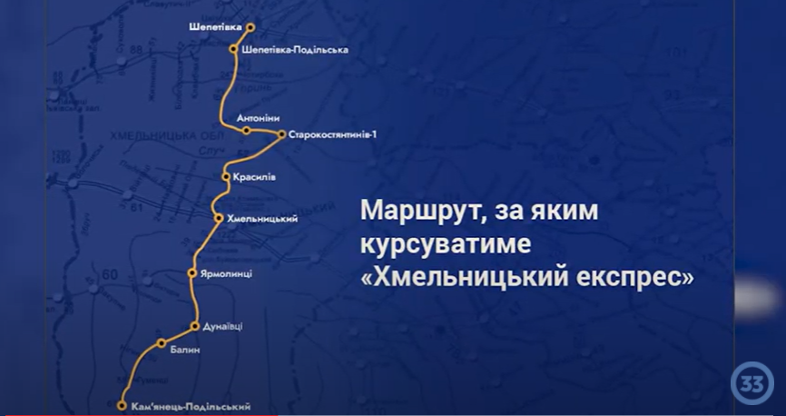
Screenshot from the news of the 33rd channel

Most regional media wrote about the launch of this train (rail bus), due to this measure is really significant for Khmelnytsky region. Hundreds and hundreds of residents of the region were waiting for the launch of this suburban railway route. A passenger from Shepetivka to Kamyanets-Podilsky can get there at an affordable price: for 85 hryvnias currently (40 hryvnias + 45 hryvnias), unlike more than 200 hryvnias by bus.
So, on August 30, the first train left Shepetivka to Kamianets-Podilskyi to allow people to easily get home from work and to move around Khmelnytsky region. At that time, according to the Khmelnytsky Regional State Administration, it was assumed that the trip would take about four hours, and the route would be served by a convenient train, which was repaired for this purpose.
"The train was repaired for 2 months, and now we see comfortable wagons with comfortable passenger seats, modern bathrooms and ventilation system. Generally, 222 seats are provided in the rail bus, it can provide transportation of all comers from Shepetivka station to Kamyanets-Podilsky station” - said Artem Myronovych, executive director of the South-Western Railway regional branch.
According to the head of the Khmelnytsky Regional State Administration Serhiy Hamaliy, “Ukrzaliznytsia” repaired a train that ran for ten years (2006-2016) specifically for this route and invested about 30 million hryvnias into the route.

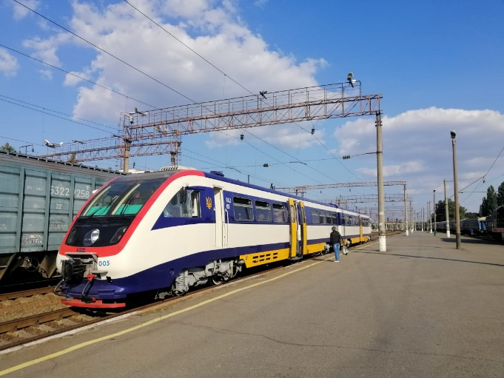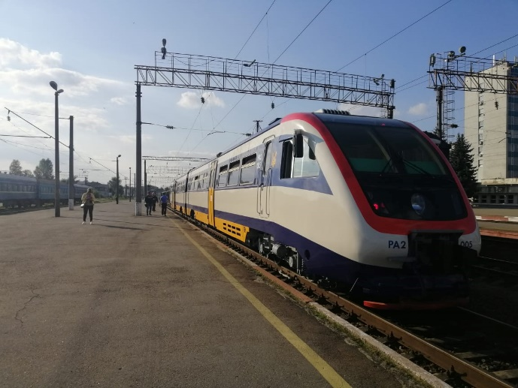
Photo by the author

To make sure that the train really runs the route and whether the declared rail bus really runs, you need to visit the central railway station in Khmelnytsky. This was done in the evening of September 8, 2021. In fact, at the stated time, namely at 5:10 p.m., the train arrived at Khmelnytskyi station and boarded passengers there until 5:24 p.m. However, it did not leave in time. It allowed the diesel train to Zhmerynka to pass and with a delay, somewhere at 17:36, started its movement from Khmelnytsky to Shepetivka. However, it was not the train itself that attracted attention, but its serviceability. It runs on the route for ten days, and the announcement "Doors do not work" has already been placed on the door of the second wagon.

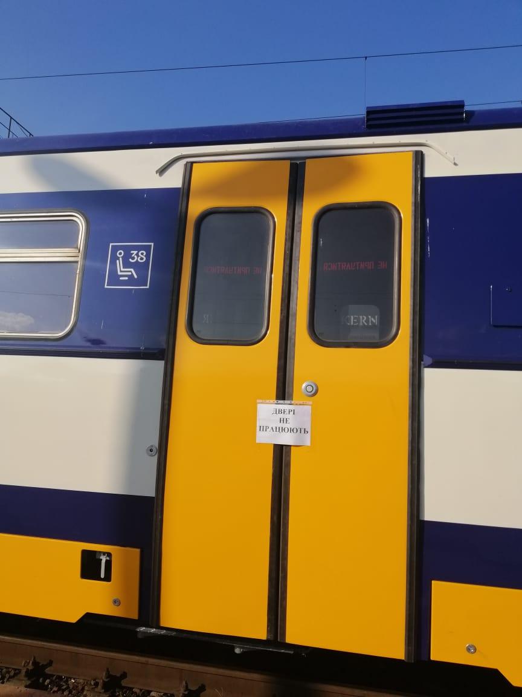
Photo by the author

Remarks

This route was awaited by a large number of residents of Khmelnytsky region, who previously used the diesel train "Larga - Kamyanets-Podilsky - Grechany - Khmelnytsky". With the help of protests, the residents regularly raised the urgency of solving the problem of transport communication between the settlements of Khmelnytsky region. Fast and accessible transport links are extremely important as they allow citizens to take full advantage of economic, educational, cultural and social benefits. Another positive feature of the launch of this route is its affordable price.
However, the negative aspect is the speed of movement: you need to spend 7 hours and 30 minutes to cover the entire distance with a stop in the regional center (there is a loss of time at the station "Khmelnitsky"). At the same time, the road by bus takes a little more than 5 hours. Also, the mystery remains: why the front door has stopped functioning in one of the two available wagons after ten days of operation of the train?
It is worth analyzing the economic component of the operation of this train route and the tariff policy, because in case the train is unprofitable again, its functioning will sooner or later be stopped anyway.
At the same time, the Khmelnytsky Regional State Administration's statement that the current train launch is the first example of successful cooperation between local authorities and JSC “Ukrzaliznytsia” is questionable due to there are many examples of quite successful cooperation between “Ukrzaliznytsia” and local authorities in Ukraine.

Scores: Quality [2.33] Relevance [71.67%]

V. A new "Open Data Portal" has been developed in Dnipro

Features of the measure:

A new "Open Data Portal" is being introduced in the Dnipro city. Dnipro became one of the first cities to introduce a new portal, as the city has all the necessary technical capacity. 1,169 data sets were available on the previous Dnipro Open Data Portal; the process of transferring it to a new website and conducting an audit of public information is underway.
The city authorities have concluded a license agreement with the Ministry of Digital Transformation of Ukraine. After the introduction of the new licensed software, the information will be automatically uploaded to the state open data portal. In this way, it will significantly reduce the time for specialists to process and download the information and will provide an opportunity to promptly publish new data sets for citizens, will simplify access to public information for citizens to analyze, to develop innovative attractiveness and to prevent corruption.

Reference
Open data is information that should be published by public authorities in open access for all citizens and in machine-readable format on the Unified State Open Data Portal. Discovering data has made it easier for businesses and the public to find the information they need. This data is an important source of information on the state of a particular industry and an effective tool for combating corruption through openness and transparency of information for everyone. Through the use of open data, professionals create a variety of services and applications that help citizens in various spheres of life. For example, the “Dnipro GPS Inclusive” mobile application is based on information about public transport, its routes, hours of operation and stops for the visually impaired, and has voice guidance that helps to navigate in space and tp determine the route.
Remarks

The Dnipro is getting closer to the changes in the direction of openness and transparency of Ukrainian cities. Openness of data and its compilation on one portal is a very good measure, however such an initiative should be done at the national or regional level, not at the city level. Such portals are needed by all territorial communities.
There is also a need to see how convenient and large the portal turns to be. It is important for the data to be updated periodically, fully and in a format convenient for processing. Additionally, the city council does not report at whose expense the new portal was developed and how much money was spent on it. Information on the number of staff involved in processing and publishing the open data, and ideally an estimate of their workload, would be useful. At present, it seems that the city council has somewhat improved its handling of open data, which is, of course, a positive thing, but without additional information it is difficult to assess the feasibility of the resources spent on it.

Scores: Quality [2] Relevance [60.83%]

VІ. The work of the Institute of Commissioners for Prevention and Detection of Corruption in Local Self-Government Bodies

Features of the measure:

The Institute of Commissioners for Prevention and Detection of Corruption in Local Self-Government Bodies has had virtually no impact on current corrupt practices over the past five years.
Schemes are active in communities and generate income for new, and sometimes old, beneficiaries. Today, the power, political influence and proximity to resources (land, property, budgets) allow you to get rich much faster than in business. Theft and abuse occur at all levels: from the theft of fuel at a utility company to the creation of preferences for individual businesses to sell goods, works and services in the community.
The introduction of the institution of anti-corruption commissioners should have helped to destroy corruption practices. Instead, the system pushes out some really effective anti-corruption activists, and most of them turn into clerks who help to fill out declarations, resolve conflicts of interest, and conduct various trainings and briefings. They also prepare anti-corruption programs, which are mandatory for local governments, but are questionable in their impact on corruption. According to the National Agency on Corruption Prevention (NACP) register, the Lviv City Council does not have a commissioner for the prevention and detection of corruption, but there is a sector of integrity that performs such functions. Despite the existence of such a unit, over the past few years, law enforcement officers have detained city council officials and utility managers during bribery.
Such situations are not uncommon and occur not only in Lviv but also in other local self-government bodies. In particular, an official of the Drohobych City Council was detained while receiving a bribe while there is a commissioner for prevention and detection of corruption in Drohobych. An official of the Stryj City Council was detained while trying to bribe, and the Commissioner for Prevention and Detection of Corruption knew nothing about the existing scheme.
At the same time, the anti-corruption infrastructure is mainly aimed at "catching" violators and does not eliminate systemic shortcomings, for example in the legislation that allows directing budget funds to private pockets.
Why don't community anti-corruption programs work?
According to the research conducted by the NACP on the effectiveness of anti-corruption commissioners:
- 20% of programs are not approved by the NACP at all;
- only 44% of program activities are coordinated or implemented by commissioners;
- 60% of authorities do not report on the status of implementation of their programs;
- 61% of authorities do not review these programs during the year;
- 91% do not involve external stakeholders in their review or evaluation.
At the same time, there are cases when anti-corruption programs are not approved by the local self-government. In particular, the Lviv City Council has not approved an anti-corruption program for the current year 2021, and it is still under discussion.
The NACP does not even evaluate the effectiveness of anti-corruption programs, as their indicators do not allow assessing the effectiveness of the measures specified in such programs. After all, it is difficult to assess the implementation of a measure such as "ensuring the control over the existence of the conflict of interest of local council deputies" with the deadline "constantly". Moreover, the measures provided by the programs are often reduced to conducting briefings on the topic that corruption is evil.
This approach does not allow to systematically solve the problems with corruption, for example, to change the legislation with the aim to eliminate corruption schemes.
An important problem is that anti-corruption activists do not have the opportunity to work to eliminate corruption schemes because they are dependent on the head of the authority, who can dismiss them if their activities interfere with corruption schemes in that institution. Other employees also do not want an anti-corruption activist to "interfere" in their activities. Anti-corruption commissioners often do not have the necessary competencies, influence and understanding of the subject, due to the activities of the institution can be quite broad. The anti-corruption commissioners themselves complain about the lack of time, because during the annual declaration they are torn to pieces by colleagues with requests to help them with filling in the declarations.
Thus, the activities of anti-corruption commissioners are limited to filling out the declarations that do not affect the destruction of corruption schemes, to briefings that do not force to behave honestly, and to the settlement of conflicts of interest, which everyone has learned to avoid, and to creation of anti-corruption programs that have no practical use.

Remarks

Unfortunately, the work of the commissioners for the prevention and detection of corruption in local self-government bodies is not successful in the most cases. Despite the innovations in the legislation, there is no effective impact.
The case of the Lviv City Council, where the anti-corruption program for the current year has not been approved, can hardly be assessed quite negatively, although this practice contradicts the requirements of the legislation. The article itself states the ineffectiveness of these programs and their formal nature.
Thus, it cannot be ignored that the deputies may try to fill the mandatory nature of the program with a very real content and functionality, which will make such a program to be a serious safeguard against corruption. Of course, it will be possible to draw final conclusions after the analysis of the approved anti-corruption program (or the lack of the approved program by the end of the year). It is often much easier to introduce radical changes by adopting a new document rather than by trying to make changes in the existing and already familiar to deputies programs.
If the institution of commissioners functions in the above-mentioned way, then the commissioners will really only help the deputies to fill in the declarations. The approach according to which the commissioners will work under the direction of the NACP may be the way to solve the problem. Let it be ten people for the whole region, but they will have the power to prevent and combat corruption.

Scores: Quality [-2.2] Relevance [60.6%]

Investigated by: Toponen Yulia - Community facilitator, Charity Fund Caritas Mariupol
Investigated by: Protsenko Yulia - Economist-analyst, ICPS
Investigated by: Katolyk Iaroslav - Regional coordinator of the projects
Investigated by: Bereza Alyona - Regional project coordinator, Head of the NGO “Women's anti-corruption movement”
Investigated by: Kuzko Yuriy - Executive director of the NGO "Center for Public Monitoring and Research"
Investigated by: Blinov Oleh - Analyst of the NGO “Center for Public Monitoring and Research”

